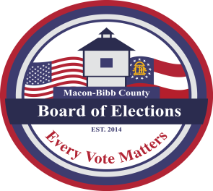
MACON-BIBB COUNTY
BOARD OF ELECTIONS
3661 EISENHOWER PKWY, SUITE MB101
MACON, GEORGIA 31206

Thomas Gillon
ELECTIONS SUPERVISOR
Tgillon@maconbibb.us
Phone: (478) 621-6622
Fax: (478) 910-2365

GEORGIA, BIBB COUNTY

OFFICIAL PUBLIC NOTICE OF PREPARATION AND TESTING OF VOTING EQUIPMENT

Pursuant to O.C.G.A. §21-2-379 (6)(c); O.C.G.A. §21-2-379.25; & SEB Rule 183-1-12-.08, the voting equipment for use in the General Primary and Non-partisan General Runoff Election being held on Tuesday, June 16, 2026, will be inspected as listed below.
Logic and Accuracy testing of the voting equipment being utilized for absentee balloting and for all Bibb County polling locations will commence at 9:00 AM on Monday, June 1, 2026, and will continue thereafter until testing is complete. This testing will be conducted at the Macon-Bibb County Board of Elections office located at 3661 Eisenhower Parkway, Suite MB101, Macon, GA 31206
THIS INSPECTION IS OPEN TO THE PUBLIC
Thomas Gillon, Elections Supervisor

