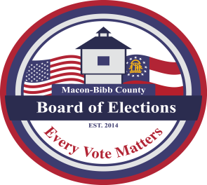
MACON-BIBB COUNTY
BOARD OF ELECTIONS
3661 EISENHOWER PKWY., STE MB101
MACON, GEORGIA 31206
Phone: (478) 621-6622
Fax: (478) 910-2365

Board Members  Robert Abbott  Chairperson  Tom Ellington  Vice-Chair  Barbara Boyer  Member  Karen Evans  Member  Mike Kaplan  Member  Thomas Gillon  Elections Supervisor | Agenda  Regular Board Meeting  November 20, 2025  4:00 P.M.  - Call Board Meeting to Order  Approval of Minutes for the meeting held October 16, 2025.  - Public Comments (Limited to TWO (2) Minutes)  - Other Business  - Staff Reports  - Registered voter numbers  - Active: 105,279  - Inactive: 10,594  - Combined Total: 115,873  - This data is accurate as of date: 11/19/2025  - GARVIS Dashboard Report  - DDS Department Driver Services Applications – 2,485  - OLVR – Online Voter Registration Applications – 84  - Verification of Pending Voters – 285  - Elections Supervisor – Thomas Gillon  - Risk Limiting Audit update  - Legal Reports  - Public Comments (Limited to TWO (2) Minutes)  - Motion For Adjournment

