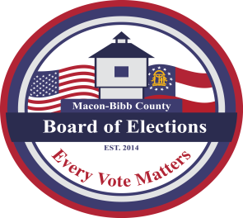

**MACON-BIBB COUNTY**

**BOARD OF ELECTIONS**

3661 EISENHOWER PKWY., STE MB101

MACON, GEORGIA 31206

**Phone: (478) 621-6622**

**Fax: (478) 910-2365**

|  |  |
| --- | --- |
| **Board Members**  Robert Abbott  **Chairperson**  Tom Ellington  **Vice-Chair**  Barbara Boyer  **Member**  Karen Evans  **Member**  Mike Kaplan  **Member**  Thomas Gillon  **Elections Supervisor** | **Agenda**  **Regular Board Meeting**  **August 21, 2025**  **4:00 P.M.**   1. **Call Board Meeting to Order**   Approval of Minutes for the July 21, 2025 meeting.   * 1. **Public Comments (**Limited to **TWO (2) Minutes)**  1. **Old Business** 2. **New Business**    1. **Proposal to change by-laws** 3. **Other Business**    1. **Staff Reports**       1. **Registered voter numbers**          * *Active: 109,477*          * *Inactive: 10,462*          * *Combined Total: 119,939*          * *This data is accurate as of date:*          * ***GARVIS Dashboard Report***             1. *DDS Department Driver Services Applications – 2837*            2. *OLVR – Online Voter Registration Applications – 30*            3. *Verification of Pending Voters – 257*       2. **Elections Supervisor – Thomas Gillon**  * GAVREO conference summary   1. **Legal Reports**   2. **Public Comments (**Limited to **TWO (2) Minutes)**  1. **Motion For Adjournment** |
|  |  |