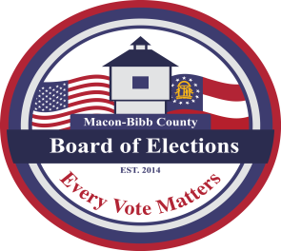

MACON-BIBB COUNTY
BOARD OF ELECTIONS
2525 PIO NONO AVENUE, SUITE 1200
MACON, GEORGIA 31206
Phone: (478) 621-6622
Fax: (478) 621-6119

Board Members  Joel Hazard  Chairman  Karen Evans-Daniel  Member  Mike Kaplan  At-Large Member  Tom Ellington  Member  Robert Abbott  Member  Thomas Gillon  Interim Elections Supervisor | Agenda  Regular Board Meeting  Thursday May 18, 2023  4:00 P.M.  - Call Board Meeting to Order  Approval of Minutes for the April 20, 2023 meeting.  - Old Business  a. Fifth member nominations submitted to Commission April 26, 2023  - New Business  - Other Business – Staff Reports  - Deputy Registrar – Angelia McLean  This data is accurate As of Date:  - Active Voters:  - Inactive Voters:  - Combined Total Voters:  - GARVIS Voter Registration Dashboard Report  - DDS Department Driver Services Applications:  - OLVR – Online Voter Registration Applications:  - Verification of Pending Voters:  b. Interim Elections Supervisor – Thomas Gillon  - Relocation Staff Tour to Macon Mall  - Vehicles  - 2024 Election Schedule  c. Legal Reports – William Noland  - Senate Bill 129 - Passed  - Public Comments  - Limited to TWO (2) Minutes  - Motion For Adjournment

