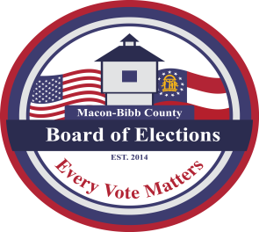

MACON-BIBB COUNTY
BOARD OF ELECTIONS
2525 PIO NONO AVENUE, SUITE 1200
MACON, GEORGIA 31206
Phone: (478) 621-6622
Fax: (478) 621-6119

Board Members  Mike Kaplan  Chairman  Karen Evans-Daniel  Vice-Chair  Joel Hazard  Member  Thomas Ellington  Member  Robert Abbott  Member  Thomas Gillon  Interim Supervisor | Agenda  Regular Board Meeting  Thursday, April 20, 2023  4:00 P.M.  - Call Board Meeting to Order  Approval of Minutes for the March 16, 2023 meeting  - Old Business  - New Business  - Welcoming new board members  Robert Abbott, Republican Party Appointee  Thomas Ellington, Democratic Party Appointee  - Select Board officers (Chair & Vice Chair)  - Nominations for fifth member  IV. Other Business - Staff Reports  a. Deputy Registrar – Angelia McLean  This data is accurate As of Date:  - Active:  - Inactive:  - Combined Total: _  - This data is accurate as of date:  - GARVIS Dashboard Report  - DDS Department Driver Services Applications –  - OLVR – Online Voter Registration Applications –  - Verification of Pending Voters –  b. Interim Elections Supervisor – Thomas Gillon  Relocation  Vehicles  Staff updates  c. Legal Reports  V. Public Comments  Limited to TWO (2) Minutes  VI. Motion for Adjournment

