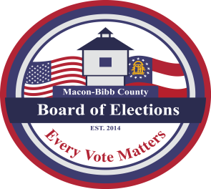

MACON-BIBB COUNTY
BOARD OF ELECTIONS
2525 PIO NONO AVENUE, SUITE 1200
MACON, GEORGIA 31206
Phone: (478) 621-6622
Fax: (478) 621-6119

Board Members  Mike Kaplan  Chairman  Karen Evans-Daniel  Vice-Chair  Joel Hazard  Member  Darius D. Maynard  Member  Herbert Spangler  Member  Thomas Gillon  Interim Elections Supervisor | Agenda  Regular Board Meeting  Thursday, March 16, 2023  4:00 P.M.  - Call Board Meeting to Order  Approval of Minutes for the February 16, 2023 meeting.  - Old Business  - New Business  - Scheduling the swearing in of new Board Members  - Nominating the Fifth Board Member (April)  - Other Business – Staff Reports  - Deputy Registrar – Angelia McLean  This data is accurate As of Date:  - Active Voters:  - Inactive Voters:  - Combined Total Voters:  - GARVIS Voter Registration Dashboard Report  - DDS Department Driver Services Applications:  - OLVR – Online Voter Registration Applications:  - Verification of Pending Voters:  b. Interim Elections Supervisor – Thomas Gillon  - Capitol Visit  - Vehicles  - Relocation to Macon Mall  c. Legal Reports  - Discussion of Senate Bill 227  - Public Comments  - Limited to TWO (2) Minutes  - Motion For Adjournment

