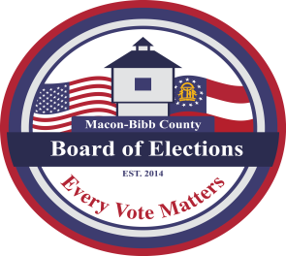

MACON-BIBB COUNTY
BOARD OF ELECTIONS
2525 PIO NONO AVENUE, SUITE 1200
MACON, GEORGIA 31206
Phone: (478) 621-6622
Fax: (478) 621-6119

Board Members  Mike Kaplan  Chairman  Karen Evans-Daniel  Vice-Chair  Joel Hazard  Member  Darius D. Maynard  Member  Herbert Spangler  Member  Thomas Gillon  Interim Elections Supervisor | Agenda  Regular Board Meeting  Friday, January 20, 2023  4:00 P.M.  - Call Board Meeting to Order  Approval of Minutes for the December 16th 2022 meeting.  - Old Business  - New Business  - Other Business  - Staff Reports  - Chief Registrar – Veronica Seals  - Active:  - Inactive:  - Combined Total: _  - This data is accurate as of date:  - ElectioNet Voter Registration Dashboard Report  - DDS Department Driver Services Applications –  - OLVR – Online Voter Registration Applications –  - Verification of Pending Voters –  - Interim Elections Supervisor – Thomas Gillon  GRVIS Training  Poll Pad replacement  - Legal Reports  - Public Comments  - Limited to TWO (2) Minutes  - Motion For Adjournment

