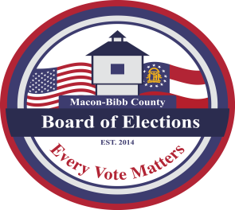
Phone: (478) 621-6622
Fax: (478) 621-6119
MACON-BIBB COUNTY
BOARD OF ELECTIONS
2525 PIO NONO AVENUE, SUITE 1200
MACON, GEORGIA 31206

Board Members  Mike Kaplan  Chairman  Karen Evans-Daniel  Vice-Chair  Joel Hazard  Member  Darius D. Maynard  Member  Herbert Spangler  Member  Thomas Gillon  Interim Elections Supervisor | Agenda  Special Call Meeting  Tuesday, November 22, 2022  9:00 A.M.  - Call Board Meeting to Order  - Discussion  - Early Voting Locations and Hours for December 6th Runoff  - Advance In-Person Voting Day - Saturday, November 26, 2022  - Motion For Adjournment

