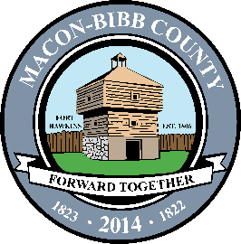

Macon-Bibb County
Procurement Department
700 Poplar Street
3rd Floor Procurement
Macon, Georgia 31201
(478) 803-0550
Fax (478) 751-7252

April 6, 2022

NOTICE OF SOLICITATION ACTION

SOLICITATION NUMBER: 22-048-LH
SOLICITATION TITLE: Coordinator for Macon Violence Prevention Program
SUBMISSION DUE DAT/TIME: 3/24/2022

The Solicitation referenced above is canceled.

