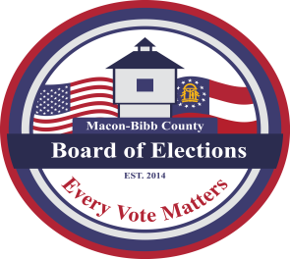

MACON-BIBB COUNTY
BOARD OF ELECTIONS
2525 PIO NONO AVENUE, SUITE 1200
MACON, GEORGIA 31206
Phone: (478) 621-6622
Fax: (478) 621-6119

Board Members  Darius D. Maynard  Chairman  Joel Hazard  Vice-Chair  Karen Evans-Daniels  Member  Mike Kaplan  Member  Herbert Spangler  Member  Thomas Gillon  Interim Elections Supervisor | Agenda  Regular Board Meeting  February 17, 2022  4:00 P.M.  - Call Board Meeting to Order  - Executive Session  - To discuss personnel matters.  - Approval of the January 20, 2022 – Board Meeting Minutes  - New Business  - Polling Place recommendation  - Early Voting Locations  - Old Business  - Candidate Qualifying for the May Gen Prim. and NP Gen. Election  - Other Business  - Staff Reports  - Chief Registrar – Veronica Seals  - Active: _________  - Inactive: ________  - Combined Total: _________  - This data is accurate as of date:  - ElectioNet Voter Registration Dashboard Report  - DDS Department Driver Services Applications – __  - OLVR – Online Voter Registration Applications – _  - Verification of Pending Voters – __  - Early Voting Update ___  - Absentee by mail update ___  - Interim Elections Supervisor – Thomas Gillon  - Legal Reports  - Board Attorney – William H. Noland  - Public Comments  - Limited to TWO (2) Minutes  Motion For Adjournment

