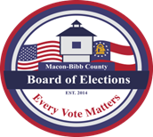
Phone: (478) 621-6622
Fax: (478) 621-6119
MACON-BIBB COUNTY
BOARD OF ELECTIONS
2525 PIO NONO AVENUE, SUITE 1200
MACON, GEORGIA 31206

Board Members

Darius D. Maynard
Chairman

Joel Hazard
Vice-Chair

Karen Evans-Daniel
Member

Mike Kaplan
Member At-Large

Herbert Spangler
Member

Jeanetta Watson
Elections Supervisor

AGENDA

Special Call Meeting
January 7, 2022
11:00 a.m.

- Call to Order
- Executive Session
- To discuss personnel matters

Motion to enter Executive Session by__________ seconded by__________

Motion to close Executive Session by__________ seconded by__________
- Approval to accept the Elections Supervisor’s Resignation

- Motion for Adjournment

