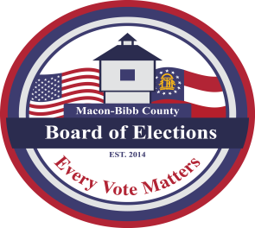
MACON-BIBB COUNTY
BOARD OF ELECTIONS
2525 PIO NONO AVENUE, SUITE 1200
MACON, GEORGIA 31206
Phone: (478) 621-6622
Fax: (478) 621-6119

Board Members  Darius D. Maynard  Chairman  Joel Hazard  Vice-Chair  Karen Evans-Daniels  Member  Mike Kaplan  Member  Herbert Spangler  Member  Jeanetta R. Watson  Elections Supervisor | Board Meeting Agenda  October 21, 2021  4:00 PM  - Call to Order  - Approval of September 20, 2021, Regular Board Meeting Minutes  Approval of the October 1, 2021, Special Called Meeting Minutes  - New Business  - O.C.G.A. 21-2-90; Approval of Poll Manager Appointment for the November 2, 2021, Special Election  - Request approval to schedule the November Board meeting to Friday, November 5, 2021, at 6:00 p.m. for any potential challenge hearings and certification of the election results  - Old Business  - None  - Other Business  - Staff Reports  - Elections Officer – Tom Gillon (Campaign Finance Report)  - Chief Registrar – Veronica Seals  - Active: _107,287________  - Inactive: __7,563______  - Combined Total: 114,850_________  - This data is accurate as of date: October 20th___, 2021  - ElectioNet Voter Registration Dashboard Report  - DDS Department Driver Services Applications – 295__  - OLVR – Online Voter Registration Applications – 21__  - Verification of Pending Voters – 0__  - Early Voting Update 1,033 (10/12 – 10/20/21)  - Absentee by mail update 415 ballots mailed  & 141 returned  - Elections Supervisor – Jeanetta R. Watson  - Next Scheduled State Election Board Meeting for approval to amendments to SB 202 – October 28, 2021, at 9:00 a.m. via the zoom registration link below  - https://sos-ga-gov.zoom.us/webinar/register/WN_ALriR5naQ_SJIOW6zXFNWw  - Legal Reports  - Board Attorney – William H. Noland  - Public Comments  - Limited to TWO (2) Minutes  Motion For Adjournment

