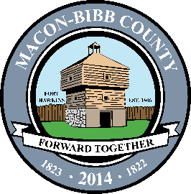

Macon-Bibb County
Procurement Department
700 Poplar Street
3rd Floor Procurement
Macon, Georgia 31201
(478) 803-0550
Fax (478) 751-7252

January 28, 2021

NOTICE OF SOLICITATION ACTION

SOLICITATION NUMBER: 21-026-FH
SOLICITATION TITLE: County Manager Official Vehicle Hyundai Palisade
SUBMISSION DUE DATE/TIME: January 28, 2021 12:00 p.m.

The Solicitation referenced above is canceled and hereby all bids rejected as all responsive bids came in over budget.

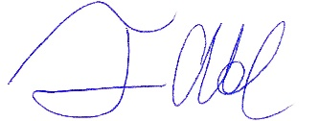
Frank A. Howard
Procurement Officer

