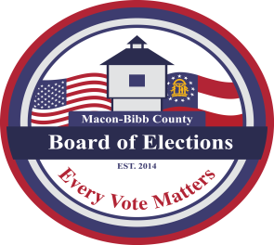
MACON-BIBB COUNTY
BOARD OF ELECTIONS
2525 PIO NONO AVENUE, SUITE 1200
MACON, GEORGIA 31206

Phone: (478) 621-6622
Fax: (478) 621-6119
Jeanetta R. Watson
ELECTIONS SUPERVISOR
jwatson@maconbibb.us

AGENDA

SPECIAL CALL MEETING
TUESDAY, MAY 19, 2020
“HELD VIA TELECONFERENCE”

CALL TO ORDER: Mr. Kaplan, Chairperson called the meeting to order at ______ a.m.

RECOGNITION OF VISITORS:
- Welcome & Recognition of Visitors via Teleconference

NEW BUSINESS:
- Discussion to remedy ballots issued for Congressional District (2) which was included in Congressional District (8) (ACTION)
ADJOURNMENT:

- Motion for adjournment at ___________ a.m.

