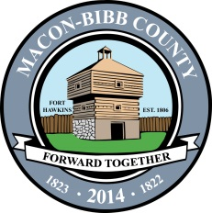
Business Development Services
200 Cherry Street, Suite 202
Macon, GA 31201

Permit Holder Affidavit

For Projects Involving Demolition, Wrecking or Renovation

The undersigned hereby acknowledges that the issuance of this permit does not in any way grant permission to the owner, owner’s representative or permit holder to proceed with demolition, wrecking, or renovation prior to the filing of the ten day “Project Notification For Asbestos Renovation, Encapsulation or Demolition” required by Georgia Law and administered by the Georgia Environmental Protection Division. In most cases, Georgia Law requires both the owner and demolition contractor to assure the building is thoroughly inspected by an Accredited Asbestos Inspector for materials that contain asbestos and requires notification even if no asbestos is present in the building. Other environmental issues such as asbestos removal, lead abatement, ground contamination, etc., may have EPD regulations that could affect your project.

Project Address: ______________________________________

Print Name: __________________________

Signature: ___________________________ Date: ___________
_________________________________________________________
Office Use Only:

Permit Number: ________________________________ Processed By: __________________________________________

