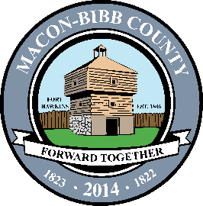

Macon-Bibb County
Procurement Department
700 Poplar Street
3rd Floor Procurement
Macon, Georgia 31201
(478) 803-0550
Fax (478) 751-7252

Chauncey Wilmore
Senior Procurement
April 6, 2017

NOTICE OF SOLICITATION ACTION

SOLICITATION NUMBER: 17-019-KMB
SOLICITATION TITLE: Guardrails Replacement & Repair
SUBMISSION DUE DAT/TIME: March 9th, 2017 2:00 PM

RESPONDENTS: 0 Submissions received

Company Name | Location
RESULTS: Cancellation due to know responses.

________________________________
Kimberly Bradley
Procurement Officer III

