Lake Tobesofkee Christmas Boat Parade

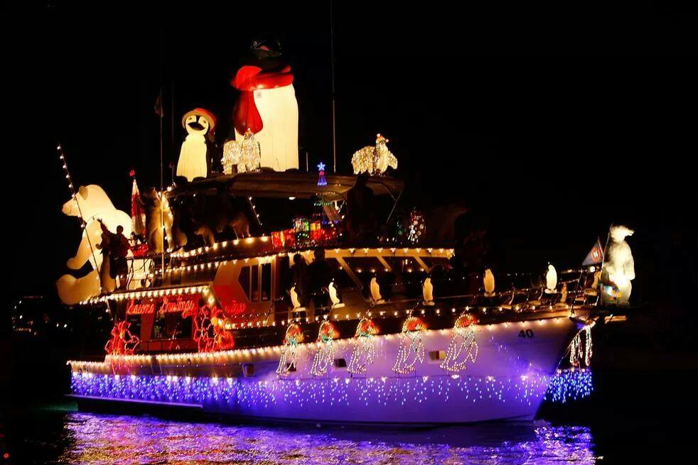

The Lake Tobesofkee Christmas Boat Parade will be held Saturday December 20, 2014, starting at 6:00 PM. Entry forms can be received by contacting: (478)474-8770

Lake Tobesofkee Christmas Boat Parade
Attn: Michelle Ware
Claystone Park
6600 Mosley Dixon Road
Macon, GA 31220

Judging will be based on variety, creativity and originality of each entrant.
Prizes and awards will be given in the following categories:
- Power Boat 3. Sail Boat
- Pontoon Boat

The winners in each category will have the “bragging” rights as the “best decorated boat” on the lake for the next year.
Deadline for entries is December 19, 2014. Parade line-up will begin at the Fish & Pig Restaurant. You will be notified of your line-up number by noon Saturday, December 20th. The Parade route will be one time up the lake to the Lower Thomaston Bridge and back to the Fish & Pig. Parade check-in will begin at 4:00 pm and you should be in place no later than 5:30 pm.

Type of entry: Power Boat ______ Sail Boat ______
Pontoon Boat _____ SUP (must have light) _____
Kayak (must have light) _____

Sponsors:
Central Ga Marina, Fish & Pig, Lizella Ace Hardware, Tobesofkee Lake Store & Tobesofkee Auto Sales

Special Olympics Georgia Sailing Center

