Minority/Women/Disadvantaged Business Enterprise Participation in Completed SPLOST Projects January 01, 2014- July 30, 2016

Of the completed vertical construction SPLOST funded projects from January 01, 2014 thru July 31, 2016, forty percent (40%) of the contract dollar awards went to DBE Prime Contractors. The contract awards total $6,150,998. In addition to the general prime contractor awards, $5,433,875 was awarded to DBE sub-contractors. This represents twenty-six percent (26%) of the total contract dollar awards for vertical construction.

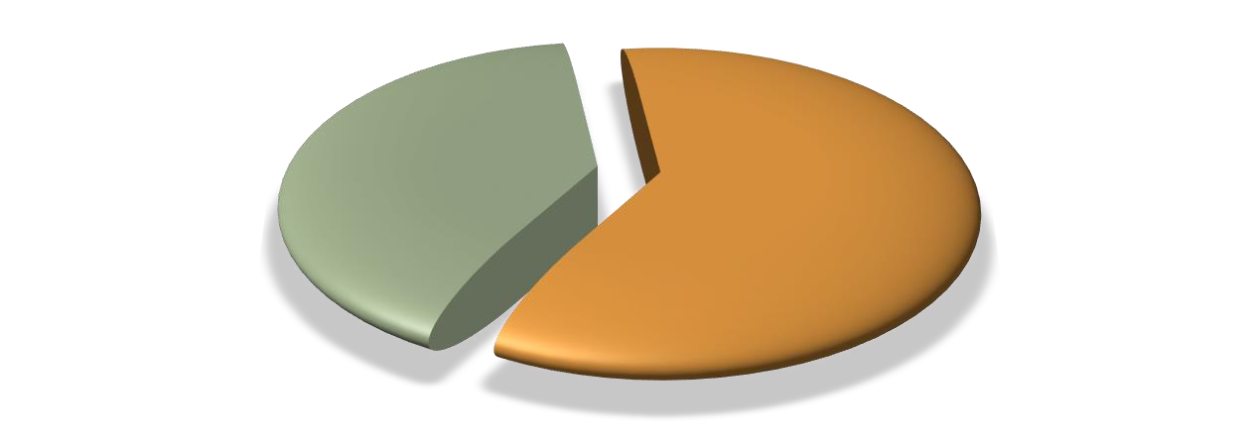
Minority
Prime
Contract
Awards
40
%
Non
-
Minority
Prime
Contract
Awards
60
%
SPLOST Completed Construction Projects
January 1, 2014
-
June 30, 2016
Total Spend $15,509,831

Asset Type | Amount
Minority Prime Contract Awards | $ 6,150,998
Non-Minority Prime Contract Awards | $ 9,358,833

Minority Sub
-
Contractor
Contract
Awards
26
%
Total Contract
Awards
74
%
SPLOST Completed Construction Projects
Minority Sub
-
Contractor Awards
January 1, 2014
-
June 30, 2016
Total Spend $15,509,831

Asset Type | Amount
Minority Sub-Contractor Contract Awards | $ 5,433,875
Total Contract Awards | $ 15,509,831

Of the completed linear construction SPLOST funded projects from January 1, 2014 thru July 31, 2016, twelve percent (12%) of the contract dollar awards went to DBE Prime Contractors. The contract awards totaled $1,077,302. In addition to the general prime contractor awards, $1,612,280 was awarded to DBE sub-contractors. This represents seventeen percent (17%) of the total contract dollar awards for linear construction.

Minority Prime
Contractor
Contract Awards
12
%
Total Contract
Awards
88
%
SPLOST Completed Road Construction Projects
Minority Prime Contractor Awards
January 1, 2014
-
June 30, 2016
Total Spend
-
$7,763,868
Asset Type | Amount
Minority Prime Contractor Contract Awards | $ 1,077,302
Total Contract Awards | $ 7,763,868

Asset Type | Amount
Minority Sub-Contractor Contract Awards | $ 1,612,280
Total Contract Awards | $ 7,763,868

Minority Sub
-
Contractor
Contract Awards
17
%
Total Contract
Awards
83
%
SPLOST Completed Road Construction Projects
Minority Sub
-
Contractor Awards
January 1, 2014
-
June 30, 2016
Total Spend
-
$7,763,868

